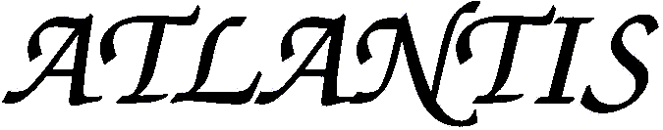

**Consent for Data Processing**

By virtue of the provisions of Regulation (EU) 2016/679 of the European Parliament and of the Council, of 27 April, on the protection of natural persons with regard to the processing of personal data, and in accordance with the Spanish regulations in force on personal data protection and guarantee of digital rights, we inform authors that their data will be incorporated into the treatment system owned by the journal *Atlantis*. The registered data will be processed by *Atlantis* for the sole purpose of managing and processing the publication and dissemination of the work of the author, Mr/Ms _________________________________________________________, who hereby gives his/her consent. The legitimate basis of this treatment is the execution of a contract and the corresponding legal obligation of the journal *Atlantis*, which undertakes not to transfer such data except as legally provided and to adopt the measures legally provided to prevent alteration, loss and unauthorised treatment or access. Likewise, authors are informed that their data will be kept for the period strictly necessary to comply with the aforementioned precepts and that they may revoke their consent, as well as exercise the rights of access, rectification, cancellation, limitation to treatment, suppression, portability and opposition by means of an electronic mail addressed to the General Editor of the journal *Atlantis*. Optionally, authors could go to the competent control authority to present the claim that they consider appropriate.

Date: ___________________________________ Signature: ______________________________